Challenge 2: Draw a donut

Suggested time: 15 minutes
A student is writing a program to draw a donut with pink frosting and chocolate sprinkles. The program uses turtle graphics to generate a picture like the one below:
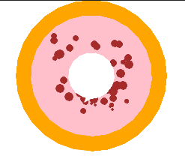
Example output from the working code
Using the file
Amend the code to add or complete lines to
- import another module needed by the code on original line 7
import
- create an constant called SPRINKLE_COUNT and set it to the integer value fifty on original line 18
SPRINKLE_COUNT =
- draw a circle with a radius of 80 at x = 0, y = 20 on original line 49
draw_circle( , , FROSTING_COLOUR, )
- make the next block of code repeat SPRINKLE_COUNT times on original line 52
for i in (SPRINKLE_COUNT):
- draw one circle over the top of the donut to be the hole in the middle on original line 59
(0, 70, BACKGROUND_COLOUR, 30)
Do not add any additional functionality
Instructions
Download the coding file DONUT.py
Remember to attach the completed code to the Teams assignment.

Watch the youtube video to check your answers https://youtu.be/9LGI__N0XXg?si=o6eQomxnEjCr58LU

A self marking online version of this challenge can be found here:
https://create.withcode.uk/python/GiX

